 | KENDRIYA VIDYALAYA tamenglong
 | SUMMATIVE ASSESSMENT-I ( 2016-17)
 | Class: IV
 | Subject: MATHEMATICS | Time: 2 Hours | Date :……….………
 | Name of the Student: ………………………………… |  | Roll No: ……………

COMPETENCIES | CONCEPT |  | ABILITY TO COMPUTE | PROBLEM SOLVING ABILITY | OVERALL
COMPETENCIES | KNOWLEDGE | UNDERSTANDING | ABILITY TO COMPUTE | PROBLEM SOLVING ABILITY | OVERALL
GRADES OBTAINED

Signature of the Invigilator ……………………… Signature of the Evaluator ……………………

CONCEPT
KNOWLEDGE
1)Answer the following.
a) 1 Litre = _____________ mililitres .
b) 1 Hour = __________ minutes .
c) 1 Metre = __________ centimetres
d) 16 x8 = _____________
e)12+12+12 +12 +12 = _________ x 12 = ________
2) Answer the following.
a) A labour earns Rs 30 in a day .How much money will he earn in 8 days?

b) Add the following.
50 metres 35 centimetres
+ 25metres 40 centimetres
_________________________________________
------------------------------------------------------------------

c) Mounish had 1 litre of water. His friend Vamsi drank 200 ml. of water from Mounish. Now how much water left with Mounish ?

d) 60 children of class IV are going for a picnic . On the way , each of them is given 5 biscuits. Now find out how many biscuits are distributed among 60 children ?

e) The cost of 1 Brick is 5 rupees . Then How much will you pay for 100 bricks ?

UNDERSTANDING
3) Answer the following.
a) Write 20 : 30 hours in 12 hours format using AM or PM. _____________
b) Write the name of month here. 20-10 –2009 ______________
c) How many faces does a brick have ? ____________
d) 60 C.M. + ________ C. M. = 1 Metres
e) How many hands are there in a clock ? _______________

4) Answer the following.
a) Draw a Brick pattern.

b) Draw the side view of a car.

c) Draw the top view of a table.

5) Following are given some dates . Arrange them in correct order .
- February 2010 , 19 December 2010, 15 August 2010 , 25 November 2010
a)__________________________
b)___________________________
c)___________________________
d)___________________________

ABILITY TO COMPUTE
6) Answer the following.
a) 2 X 3 X 6 =___________
b) 20 litres of milk + 10 litres of milk = ____________ litres of milk
c) 30 metres – 10 metres = ______________ metres

7) Answer the following.
(a) Write the TIME shown on the clock faces :

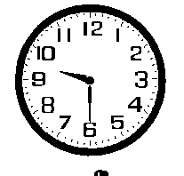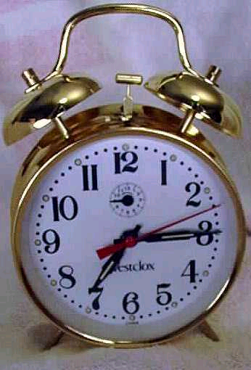

------------------------------ -------------------------------

b) A Fruit seller purchased 1 dozen of bananas for 25 rupees and sold them for 30 rupees . Then how much did he earn ?

c) The age of an elephant is 95 year old and the age of a rat is 2 year old . How much older is the elephant than the rat ?

d) The price of 1 litre of petrol is 60 rupees . Then how many rupees do you pay for 9 litres of petrol ?

8) Find out the answer from the table.

- How much money will you pay for 20 kg of newspaper ?
Meena’s Rate List
Kind of junk | price of 1 kg
News paper | Rs. 5
Iron | Rs10
Brass | Rs 50
Plasticks | Rs 8
_____________________________________
- What is the cost of 2 k.g. Iron ?
_____________________________________
- What is the cost of 4 k.g. Brass ?
_____________________________________
- What is the cost of 8 k.g. plastics ?
_____________________________________

P.S.A.
9)Fill in the blanks .
A) One hundred thousand = ___________ Lakhs .
b) In a 4000 metre race people run _____________ k.m.s.
c) 200 ml = 100 ml + _________ ml .

10)Answer the following .
a) Cost of 1000 bricks is Rs 1600 . What is the cost of 1 brick ?


50 M

b) What is the boundary of the field ? 50 M 50 M

50 M

(c) Tick the wall that will be stronger

(d) Fill in the suitable measures
700 ml
1 Litre
+ =

(e) Find the difference of: 40 L 380 ML ─ 27 L 255 ML

11) Two friends guess the time and wrote below . Tick on the correct answer
Peelu’s Answer Neelu’s Answer
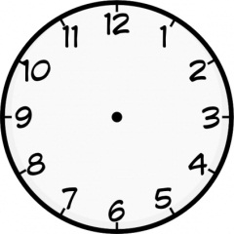 | 12:15 | 3:00
 | 4:30 | 5:30
 | 10:55 | 11:00
 | 7:35 | 8:35

